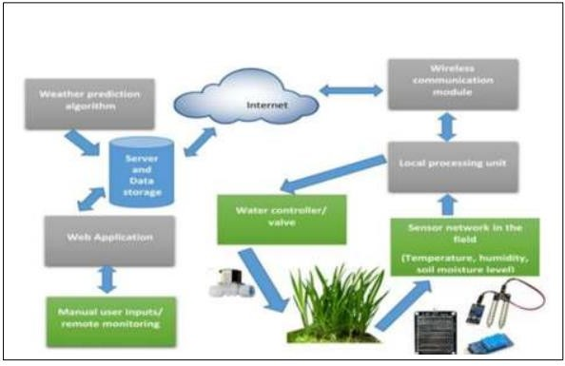

Project Design Phase-II

Data Flow Diagram & User Stories

|  |  |
| --- | --- |
| **Date** | 04 November 2022 |
| **Team ID** | PNT2022TMID27179 |
| **Project Name** | Smart Farmer-IoT Enabled Smart Farming Application |
| **Maximum Marks** | 4 Marks |
| **Submitted by** | Hemalatha N, Rajarajan .L |

**Data Flow Diagrams:**

A Data flow diagram (DFD) is a common visual representation of how information moves through a system. A clean and understandable DFD can graphically represent the appropriate quantity of the system need. It displays how information enters and exits the system, what modifies the data, and where information is kept.

Example: DFD Level 0 (Industry Standard)

**Example:** [**(Simplified)**](https://developer.ibm.com/patterns/visualize-unstructured-text/)

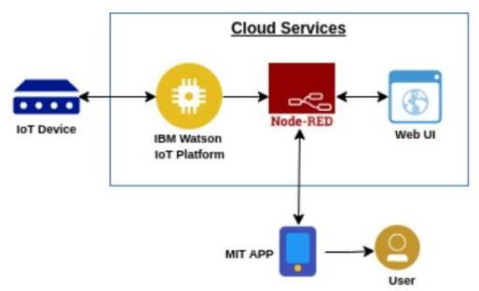

* Using various sensors, the various soil parameters, including temperature, moisture content and humidity are measured. The results are then stored in the IBM cloud.
* The Arduino UNO is utilised as a processing unit to process the data from the sensors and weather API.
* To write the hardware, software, and APIs. NODE-RED is employed as a programming tool. In order to communicate, the MQTT protocol is used.
* A mobile application created with MIT App Inventor makes all the collected data available to the user. Depending on the sensor results, the user might decide whether or not to irrigate the crop using an app. They can control the motor switch remotely by utilising the app.

**User Stories**

|  |  |  |  |  |  |  |
| --- | --- | --- | --- | --- | --- | --- |
| **User Type** | **Functional Requirement (Epic)** | **User Story Number** | **User Story / Task** | **Acceptance criteria** | **Priority** | **Release** |
| Customer (Mobile user) | Registration | USN-1 | Can register for the application by entering my email, password, and  confirming my password | I can access my account  / dashboard | High | Sprint-1 |
|  |  | USN-2 | Will receive confirmation email once I have registered for the application | I can receive confirmation email & click confirm | High | Sprint-1 |
|  |  | USN-3 | Can register for the application through Facebook | I can register & access the dashboard with Facebook Login | Low | Sprint-2 |
|  |  | USN-4 | Can Register for the application through Gmail |  | Medium | Sprint-1 |
|  | Login | USN-5 | Can Log into the application by entering email & password |  | High | Sprint-1 |
|  | Dashboard |  |  |  |  |  |
| Customer (Web user) |  |  |  |  |  |  |

|  |  |  |  |  |  |  |
| --- | --- | --- | --- | --- | --- | --- |
| **User Type** | **Functional Requirement (Epic)** | **User Story Number** | **User Story / Task** | **Acceptance criteria** | **Priority** | **Release** |
| Customer Care Executive |  |  |  |  |  |  |
| Administrator |  |  |  |  |  |  |